Internal Linking – Questions & Answers
Q1. Create a simple blog homepage with at least 3 article links.
Question:
Create an HTML homepage with 3 article links using descriptive anchor text.
Answer:
<!DOCTYPE html>
<html>
<head>
<title>My Food Blog</title>
</head>
<body>
<h1>My Food Blog</h1>
<h2>Latest Articles</h2>
<ul>
<li>
<a href="pizza-guide.html">
Best Pizza Places to Try
</a>
</li>
<li>
<a href="healthy-food.html">
Easy Healthy Food Recipes
</a>
</li>
<li>
<a href="street-food.html">
Best Street Food in India
</a>
</li>
</ul>
</body>
</html>
Why is descriptive anchor text better?
- It tells users what they will find after clicking.
- It helps search engines understand the linked page.
- It provides useful context.
- It is better than generic text such as "Click Here" or "Read More".

Q2. Draw a silo structure diagram for a food delivery website.
Question:
Show how Home, Restaurants, Offers and Blog categories and their subpages should be internally linked.
Answer:
Simple Silo Structure
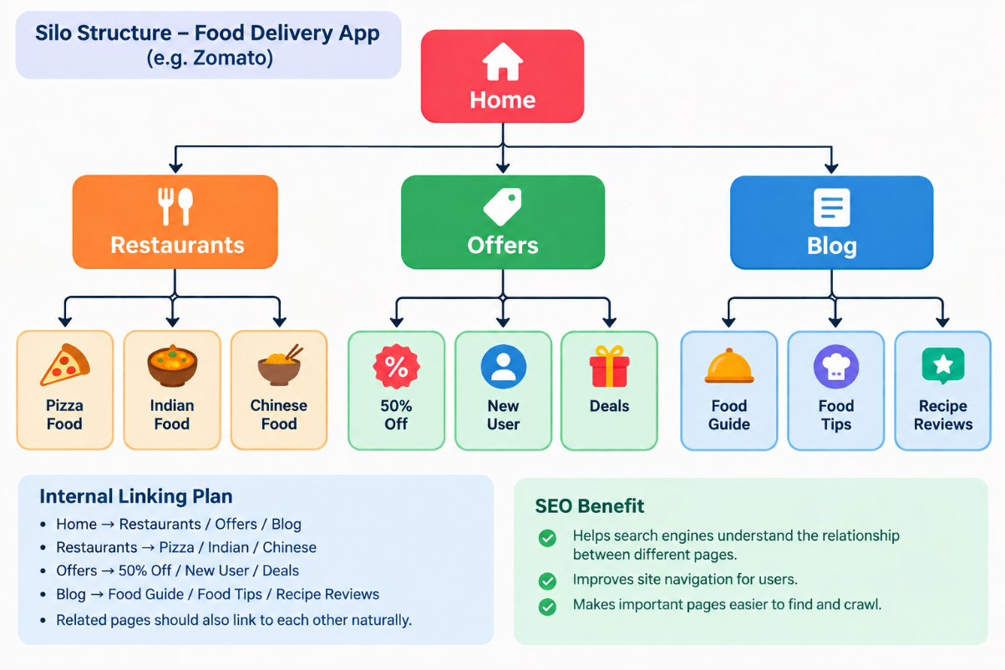
Internal Linking Plan:
- Home → Restaurants
- Home → Offers
- Home → Blog
- Restaurants → Pizza / Indian / Chinese
- Offers → Discount / New User Offers
- Blog → Food Guides / Recipes / Restaurant Reviews
- Related pages should also link to each other naturally.
SEO Benefit:
A silo structure helps search engines understand the relationship between different pages and makes website navigation easier.

Q3. Rewrite the anchor text for 4 internal links on a Flipkart-style product page.
Question:
Optimize these generic anchor texts using relevant keywords.
No. | Old Anchor Text | Improved Anchor Text
1 | See more | View more smartphones
2 | Click here for reviews | Read smartphone reviews
3 | Go to similar products | Explore similar smartphones
4 | Read about returns | View easy return policy
Why are these better?
The new anchor texts:
- Clearly describe the destination page.
- Give users more information.
- Include relevant keywords naturally.
- Help search engines understand the linked page.

Q4. Decide which 2 pages should receive the most link juice on a BookMyShow-style movie website.
Question:
Given 6 internal pages, select 2 important pages and explain why they should receive more internal links.
Answer:
Suppose the website has these pages:
- Home
- Latest Movies
- Movie Reviews
- Upcoming Movies
- Movie Tickets
- Contact Us
Pages to receive more internal links:
1. Latest Movies
This page contains current and popular movies. Many related pages can naturally link to it.
2. Movie Tickets
This page is important for users who want to book tickets. Movie pages, city pages and showtime pages can link to it.
Internal Linking Plan:
Home
|
|----> Latest Movies
| ↑
| |
|---- Movie Reviews
|
|----> Movie Tickets
| ↑
| |
|---- Upcoming Movies
Why?
More relevant internal links can help search engines discover and understand important pages. They can also make important pages easier for users to reach.

Q5. Create a topic cluster for a music streaming app.
Question:
Choose a topic cluster, identify one pillar page and at least 3 cluster pages, and explain how they should be linked.
Answer:
Topic Cluster: Music Streaming
Pillar Page:
Complete Guide to Music Streaming
Cluster Pages:
- Best Music Streaming Apps
- How to Create a Music Playlist
- Best Music for Workout
- Music Streaming Tips for Beginners
Pillar-Cluster Structure:
PILLAR PAGE
Complete Guide to Music Streaming
|
-----------------------------
| | |
↓ ↓ ↓
Best Music Create Music Best Music
Streaming Playlists for Workout
Apps
\ | /
\ | /
------ Link Back --------
to Pillar Page
How to link them:
- The pillar page links to all cluster pages.
- Each cluster page links back to the pillar page.
- Related cluster pages can also link to each other.
- Use descriptive anchor text such as "best music streaming apps" or "create a music playlist".
SEO Benefit:
The pillar-cluster model helps search engines understand the main topic and related subtopics. It also helps users easily move between related content.

